Bansilal Ramnath Agarwal Charitable Trust’s

Vishwakarma Institute of Technology, Pune-37

Department Of Artificial Intelligence and Data Science

**COMPUTER NETWORK**

# **AI2003**

|  |  |
| --- | --- |
| Division | A |
| Batch | 1 |
| Roll no | 23 |
| Name | Avishkar Ghodke |

**Write a program using TCP socket for wired network for following:**

**a. Say Hello to Each other                  b. File transfer                       c. Calculator (Arithmetic)**

Code :

Server.py   
import socket

import threading

# Server configurations

HOST = '127.0.0.1'

PORT = 1234

# Handle client communication

def handle_client(client_socket):

    try:

        # Send greeting

        client_socket.send(b"Server: Hello!")

        print("Server: Hello sent")

        # File transfer

        file_name = "server_file.txt"

        # Create a sample file

        with open(file_name, "wb") as f:

            f.write(b"This is a sample file content.")

        # Send the file

        with open(file_name, "rb") as f:

            data = f.read(1024)

            while data:

                client_socket.send(data)

                data = f.read(1024)

        # Send marker to indicate the end of file transfer

        client_socket.send(b"<END_FILE>")

        print("File sent")

        # Calculator

        while True:

            expression = client_socket.recv(1024).decode('utf-8')

            if expression.lower() == "exit":

                print("Client disconnected.")

                break

            try:

                result = str(eval(expression))

            except Exception as e:

                result = f"Error: {str(e)}"

            client_socket.send(result.encode('utf-8'))

    except Exception as e:

        print(f"Error: {e}")

    finally:

        client_socket.close()

# Start server

server_socket = socket.socket(socket.AF_INET, socket.SOCK_STREAM)

server_socket.bind((HOST, PORT))

server_socket.listen(5)

print("Server started. Waiting for clients...")

while True:

    client, addr = server_socket.accept()

    print(f"Client connected: {addr}")

    thread = threading.Thread(target=handle_client, args=(client,))

    thread.start()

Client.py

import socket

# Server configurations

SERVER_IP = '127.0.0.1'

SERVER_PORT = 1234

# Connect to the server

client_socket = socket.socket(socket.AF_INET, socket.SOCK_STREAM)

client_socket.connect((SERVER_IP, SERVER_PORT))

# Receive greeting

greeting = client_socket.recv(1024).decode('utf-8')

print(f"Server: {greeting}")

# File reception

file_name = "received_file.txt"

with open(file_name, "wb") as f:

    while True:

        data = client_socket.recv(1024)

        if b"<END_FILE>" in data:

            # Remove the marker before writing the file

            f.write(data.replace(b"<END_FILE>", b""))

            break

        f.write(data)

print("File received")

print("\n💡 Calculator (Type 'exit' to quit)")

while True:

    expression = input("Enter arithmetic expression (or 'exit' to quit): ")

    client_socket.send(expression.encode('utf-8'))

    if expression.lower() == "exit":

        break

    result = client_socket.recv(1024).decode('utf-8')

    print(f"Result: {result}")

client_socket.close()

Output

Server   
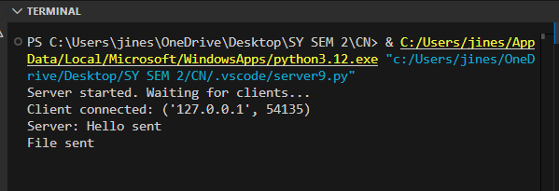

Client

